Index

Design and Evaluation 1

Design, Prototype and Construction of an Interactive Product 8

Create a Mock-up 15

Evaluation of an Interactive Product 19

# Design and Evaluation

1. Identify the needs for this product.

There are several main needs:

* Allow users to book tickets without present in front of the ticking venue; Users can book tickets online and remotely
* Users can book vast variety of tickets such as concerts, music festivals, plays, and sporting events
* Collect all the reduced tickets and discounted tickets

Needs in details:

* Old people normally do not use computer
* Young people do not have credit card to buy tickets online
* People have difficulties to find the events they like
* Too much information in one page and confused
* Do not understand English well
* No alert for the price reduced.

1. Based on your system requirements, create user profiles and produce one persona and one main scenario, explaining how a user is expected to interact with the product. Remember to keep the requirements to a minimum. Persona from Grandma Chen and several scenarios

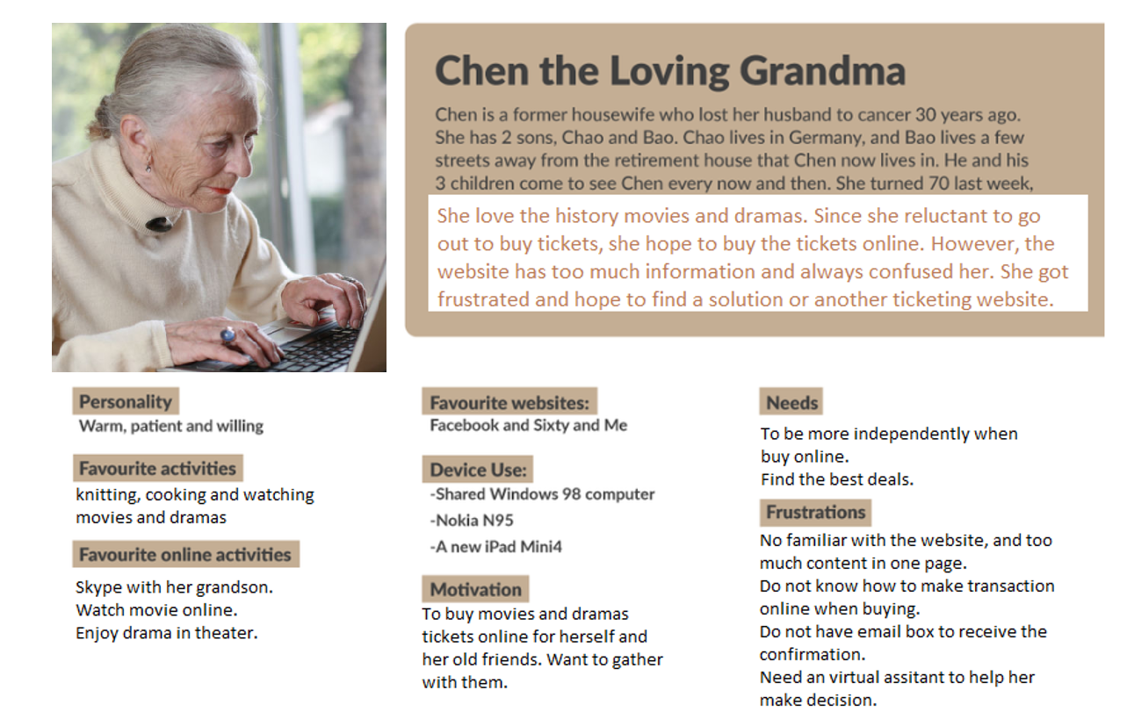

Requirement:

1. Grandma Chen can easily search the online ticking system
2. Grandma Chen can search the show on the system
3. Grandma Chen can buy the ticket easily online
4. She can register without email.
5. She can reserve the seats without filling a complication credit card information form. She can finish transaction with the virtual assistant.
6. She can choose the seats location with the virtual assistant.
7. She need to receive a confirmation letter via SMS message or mail.

1. Perform a task analysis on the activities associated with the use of the interactive product.

We can continue grandma Chen’s story. On a Wednesday morning, grandma Chen’s senior companion grandma Wu, call her and say she want to watch the drama “Pirates of the Caribbean”. Grandma Chen said she also want to watch that, and recently she heard some people mentioned about it in town. She want to check if any theatre still have the show and also have the ticket

* Step 1

Grandma search on google “Pirates of the Caribbean show”

* Step 2

The online ticketing system should be able to display in the search result easily and shown “portal for elderly citizen”. Should be easy for elderly people find out the link.

* Step 3

After grandma Chen click the “portal for elderly citizen”, she will be re-directed to the online ticketing system’s elderly people version.

* Step 4

Also, when she get the portal, the page also displays “Pirates of the Caribbean show” information as she originally searched.

* Step 5

There are several theatres have this show. The system will display all the tickets information with time, venue, theatre name and language – preferably with rating information which can help grandma make decision.

* Step 6

Grandma doesn’t know which theatre is better than the other, so here is the time for virtual assistant.

* Step 7

The virtual assistant firstly asks her living location, then budget. Then virtual assistant display the ticket options with rating. Highest rating option displays on the top.

* Step 8

Grandma choose the 1st option and wish to buy. But she need to register with phone number best and verified with SMS verification code.

* Step 9

Now she has to pay. She is doesn’t have credit card but she do have ATM debit card. With the virtual assistant’s help, she is able to pay online. And she paid.

* Step 10

Immediately she receive SMS message informing her that payment success. And afterward she received SMS message confirming her purchase, together ticket information, including time, theatre name, location, seats details and suggested transportation options. Also, the SMS message includes drama trails and beautiful introduction pirates stage images.

* Step 11

And she forward the ticket information to Grandma Wu. They can go to watch the drama together now.

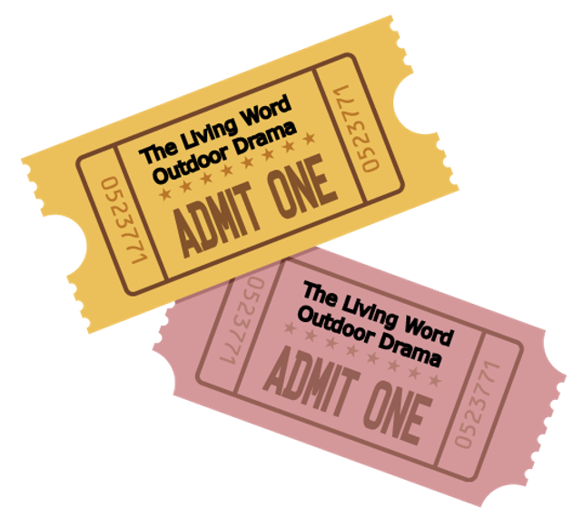 

1. Based on this analysis, produce a use case for the interactive product.

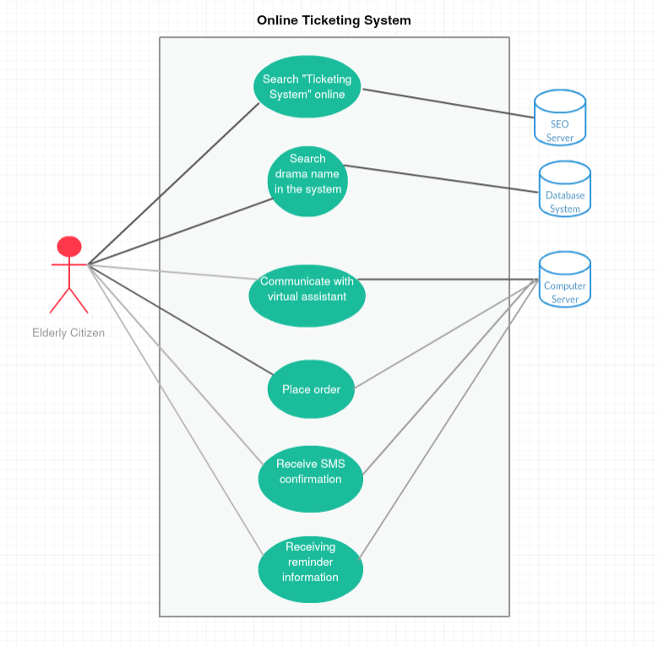

1. Using the data gathered and your subsequent analysis, identify different kinds of requirements for the product based on the topics introduced relevant topics identified in the Volere Requirements Specification Template.

##### 1). The Purpose of the Project

The purpose is to let everyone in the city can order any tickets online easily. It will enhance people’s life efficiency and do good for the economy.

1. Service goal

Make an online ticketing system which can help elderly people and citizens to order online with least effort.

1. Revenue goal

Expected to earn 1 million USD within one year after it officially launch.

1. Legal goal

Will perfectly comply with local and federal law, and be company with social responsibility.

##### 2). The Stakeholders

* 1. The clients

Both individual users and merchandises are our clients. We charge the extra service fee on both of them.

* 1. The customer

Those who registered on the system

* 1. Other stakeholders

Who invested in the startup and provide guidance and support.

* 1. The hands-on users of the products:

Those with FB account and Google account. (no registration is needed)

* 1. Personas

From young to old citizens.

* 1. Priorities Assigned to Users

There is no priorities. First come first service.

* 1. User participation

It is all online and anyone can use it.

* 1. Maintenance users and service technicians

We need two IT specialist to maintain the website and provide technical support to customers if they got technical issue.

##### 3). Mandated Constraints

* 1. Solution constraints

We need to adopt the virtual assistant function. To use this, we need buy special software library and hire a web developer to install it. And we need to development the payment gate way and VUI (Voice user interface)

* 1. Implementation Environment of the current system

I will be developed on windows computer and deployed in Linux server

* 1. Partner

Need to work with a solution company located in Hyderabad, India

* 1. Off-the-shelf software:

iFlytek – voice system for elderly citizens

* 1. Anticipated workplace environment

Any browsers

* 1. Schedule constraints

Need 3 hours maintenance every week

* 1. Budget constraints

10,000 USD

* 1. Enterprise constraints

Need to meet investor’s specific requirement

##### 4). Naming conventions and terminology

1. iFly - Virtual Assistant voice system
2. …

##### 5). Relevant Facts and Assumptions

Today everyone use computer and digital products. Online business is the trend we need to face

##### 6). The scope of the work

We expect to finish the product in 30 days with two software engineers.

##### 7). Business Data Model and Data Dictionary

To define the terms that will be used in the development and business process.

##### 8). The Scope of the Product

Currently the ticketing systems on the market are not friendly for old people. We want to “copy” a system while add the virtual assistant function and add a “elderly citizen purchase portal”

* 1. User interface for elderly citizen (easy to use)



* 1. Virtual assistant for elderly people:



##### 9). Functional Requirements

a.

**Requirement #:** 75 **Requirement Type:** 9 **Event/BUC/PUC #:** 7.9

**Description:** The virtual assistant should continuously record the user’s information in an open session

**Rationale:** To be able to assistant the elderly consistently even when the browser accidentally closed

**Originator:** Zebo Xiong – Chief Engineer

**Fit Criterion:** We will provide the privacy agreement and clear all the conversation session when the

user finish the transaction.

**Customer Satisfaction:** 5 **Customer Dissatisfdaction:**3

**Dependencies:** all requirement to run **Conflict:** 105

the system without virtual assistant

**Supporting Materials:** Work context diagram terms definition in section 5

**History:** Created February 29, 2020 

b.

**Requirement #:** 76 **Requirement Type:** 10 **Event/BUC/PUC #:** 7.10

**Description:** The virtual assistant should be able to said English and Chinese

**Rationale:** Some old people cannot easily read small words on the computer.

**Originator:** Zebo Xiong – Chief Engineer

**Fit Criterion:** We will provide the privacy agreement and clear all the conversation session when the

user finish the transaction.

**Customer Satisfaction:** 5 **Customer Dissatisfdaction:**3

**Dependencies:** all requirement to run **Conflict:** 106

virtual assistant without voice function

**Supporting Materials:** Work context diagram terms definition in section 6

**History:** Created March 2, 2020 

##### 10). Look and Feel Requirements

Looks healthy and refreshing. Emotionally motivate people to use it.

##### 11). Usability and Humanity Requirements

User-friendly for elder people and provide assistant – customer service will be provided by technical staff.

The product shall be easy for 70-year-old old people to use.

The product shall let the user to avoid making mistakes.

The product shall make the users feel good to use it.

The product shall be used by old people with no training, and possibly no understanding of good English

An elderly person shall be able to use it within a short time.

The product shall be able to be used by members of the community who will receive no training before using it.

The product shall use symbols and words that are naturally understandable by the user community.

The product shall hide the details of its construction (such as software information) from the user.

##### 12). Performance Requirements

Low response delay and guarantee SMS message confirmation within 1 minutes of transaction finished.

##### 13). Operational and Environmental Requirements

7/24 open for the tickets search. Technical support provide 8am-5pm support

Speed and Latency Requirements: not more than 3 seconds click response

Safety-Critical Requirements: N/A

Precision or Accuracy Requirements: the price should be exactly the same as the theatre’s website

Reliability and Availability Requirements: the ticket price should not fluctuate within 10 minutes

Robustness or Fault-Tolerance Requirements: if the browser is closed accidentally, user can continue the conversation with the virtual assistant.

Capacity Requirements: can support 1000 people transact at the same time

Scalability or Extensibility Requirements: can also include different languages

Longevity Requirements: N/A

##### 14). Maintainability and Support Requirements

Need to buy the voice system software maintenance.

##### 15). Security Requirements

User information will be strictly protected. And any conversation is only accessible by individual users

##### 16). Cultural Requirements

The portal should have delightful color and strictly no-violence content

##### 17). Compliance Requirements

Will fully comply with local law and be able to refund if the user choose to cancel the deal

##### 18). Open Issues

N/A

##### 19). Off-the-Shelf Solutions

Some service provider from Indian.

##### 20). New Problems

- The portal does not work well in Firefox browser.

- The system does not work fast on Chinese version system

- The Chinese characters cannot display correct

##### 21). Tasks

N/a

##### 22). Migration to the New Product

Need for data migration and integrate for new products

##### 23). Risks

The system is not as strong as banking system. And the user information is only protected in certain security level and database is not well backup.

##### 24). Costs

The voice system cost 5,000 USD and software engineer contractors cost 5,000 USD

##### 25). User Documentation and Training

Will be provided by the technical staff.

##### 26). Waiting Room

N/A

##### 27). Ideas for Solutions

a. Hire two local engineers

b. Work with solution companies in Indian.

##### 

1. Product: Prepare the requirements in the style of Volere template as edited from the total list for the material provided on the course Resources section of the class website.

Included in above session.

# Design, Prototype and Construction of an Interactive Product

1. Based on the information gleaned from part 1, suggest conceptual models for this system. You should consider each of the aspects of the conceptual model discussed in chapter 11 of the text: interface metaphor, interaction type, interface type, activities to support, functions, relationships between functions and information requirements.
2. Interface metaphor

* The business analyst in the project can be the interface metaphor to help stakeholder to understand the product. Such as explain how to use it and how to interactive with the system
* The other one is YouTube tutorials to teach the users to use the system
* The third one is to use web pages with animation to convey the usage of the system

1. Interaction type

* User will open a computer and interact with computer with mouse, keyboard, and voice.
* Also, there will be customer support hotline
* Interact with virtual assistant when chat with it.

1. Interface type

* Webpages which supported by multiple browsers
* VUI – which also support voice user interface for those who cannot operate well in system

1. Activities to support

* Search the specific events information (such as drama or performance)
* Pay online with credit card
* Pay with phone with debit card

1. Functions

* Easy to be shown in search result (SEO)
* System with “elderly citizen portal” which is a simplified system interface. For example, less category, bigger fonts and bigger search box
* User can interact with virtual assistant (it can be a bot)
* Technical support hotline (8am – 5pm support)
* Customer service hotline (7/24 support)

1. Relationship between functions and information requirement

* The virtual assistant bot will step by step collect user’s information and response based on current information.
* Send SMS confirmation message upon user’s valid cell phone number.

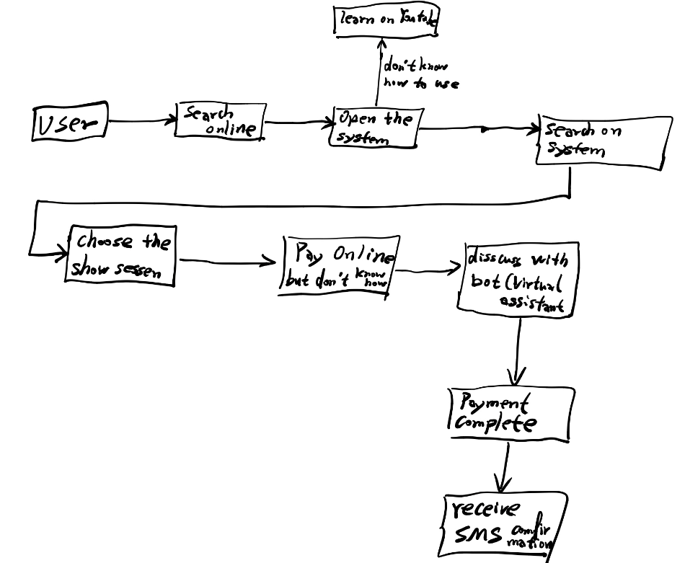

1. Produce the following prototypes for your chosen conceptual model:
2. Using the scenarios generated for the product, produce a storyboard for the task for your conceptual model. Show it to potential users and get some informal feedback.

Here is the

1. When elderly encounter online payment difficulties:

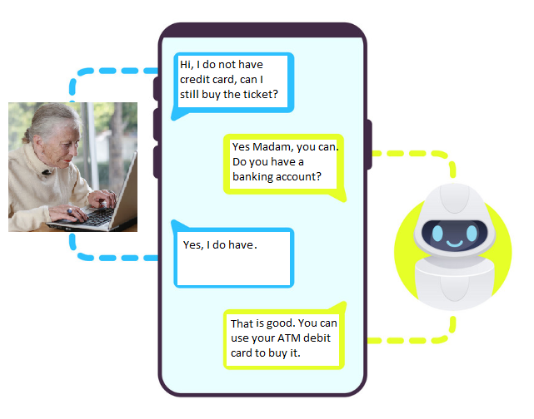

1. The bot (virtual assistant) continue help her to fill the payment form:

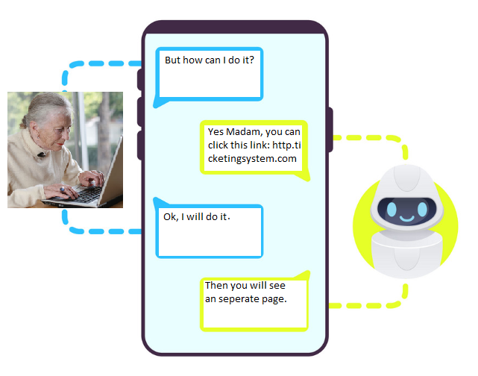

1. The old lady will fill the form to process the payment.

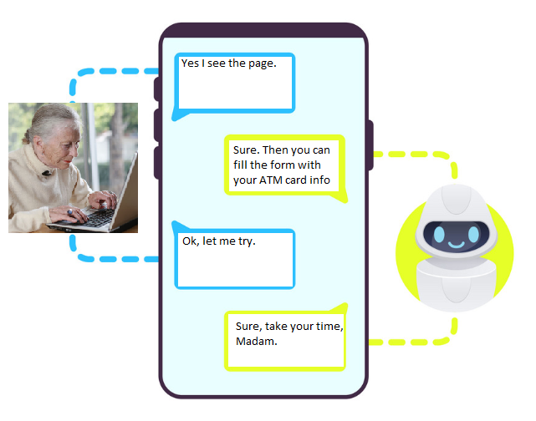

1. The lady finish transaction.

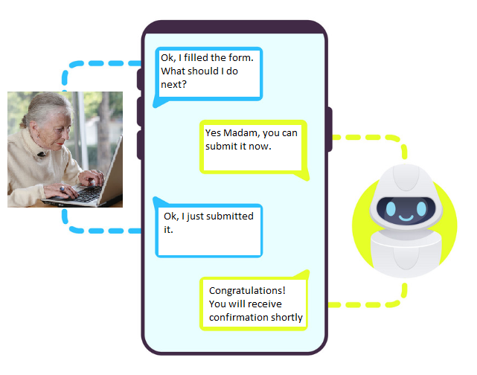

1. The bot will help send confirmation message base on the lady’s preference

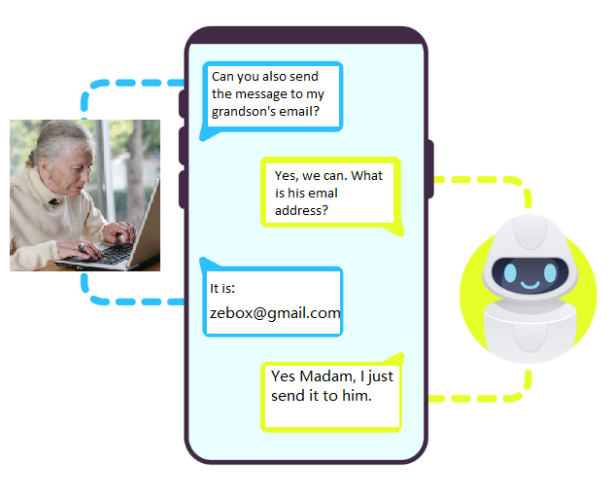

1. Develop a card-based prototype from the use case for the task, also incorporating feedback. Show this new prototype to potential users and obtain informal feedback.
2. 
3. 
4. 
5. 
6. 
7. 
8. 
9. Consider your product's concrete design. Sketch out the systems main screens. Consider the layout, use of colors, navigation, audio, animation, etc. While doing this, use the three main questions introduced in chapter 6 as guidance: (1) Where am I? (2) What's here? (3) Where can I go? Write one or two sentences explaining the choices and consider whether the choice is a usability consideration or a user experience consideration.
10. Main page

Here is the page when you first open the system. There are lots information inside.

- Here you can switch to “Elderly Citizen Portal”

- Here you have some recommended event pages.

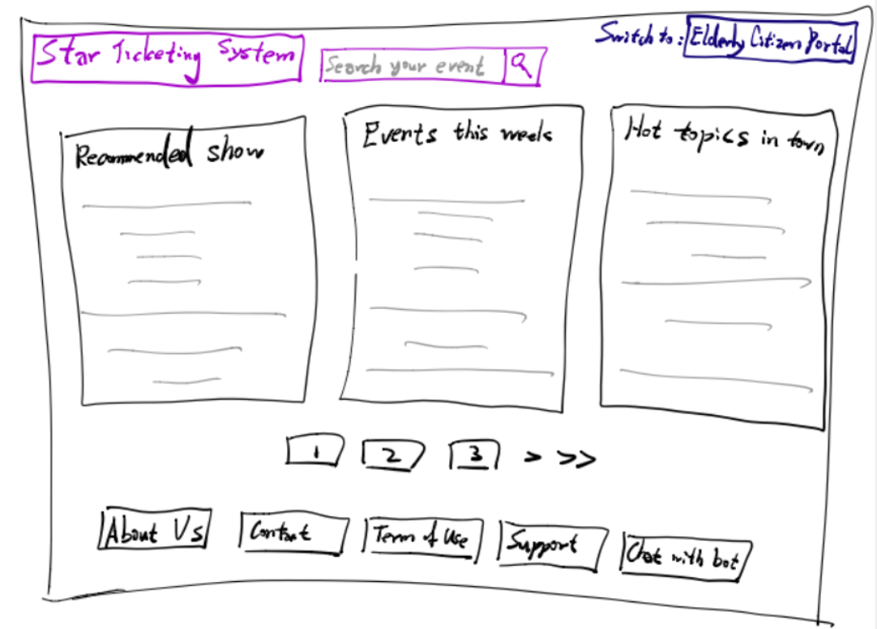

1. After switching to “Elderly Citizen Portal”, you will see below page:

- It is more simple

- No more advertising and no more recommended events

- There is only an event search bar in the center

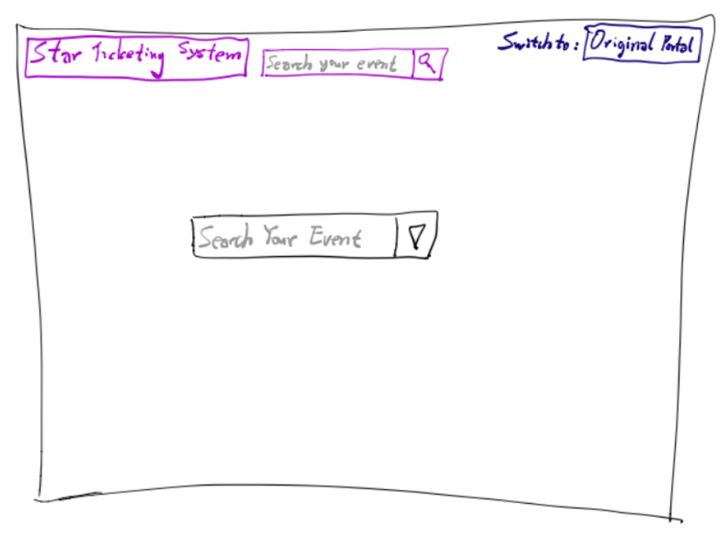

1. After search, user will get several results back. Also, the bot come out to hep user to find the best deal

- The bot (virtual assistant) can even help elderly people finish the online transaction

- User can either click the result, or chat with bot

- Or, user can start a new search by search on top of the page

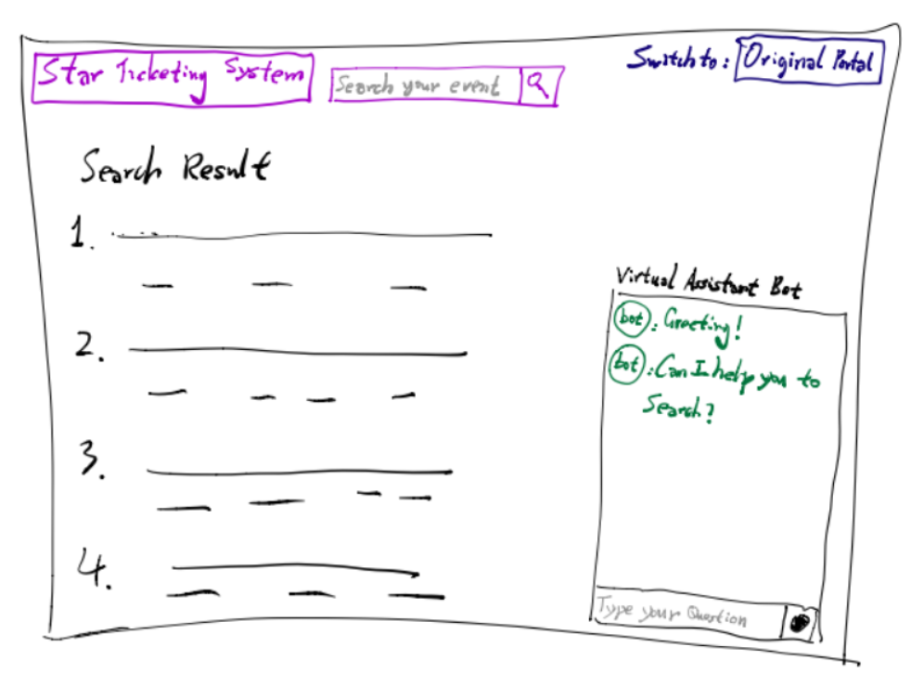

1. Sketch out an experience map for your system. Use the scenarios and personas you have already generated to explore the user's experience. Identify any new interaction issues that you had not previously considered and suggest what you could do to address them. The final product of this step should be the design of the prototype for the Interactive Product.

Experience Map:

1. Grandma want to find the drama information 🡪
2. Grandma search on Google “Pirates of the Caribbean show” and get research results
3. Grandma found a link saying “Ticketing portal for elderly citizen” on the sub-result of the returning result
4. She opened it, **however, she cannot see any tickets related to “Pirates”**
5. Thus, she need to make further action
6. There is a search bar in the center of the page. She type “Pirates of the Caribbean show”
7. Finally she saw a selection box which let her to choose the show location and time
8. **However, there is no language preference. She cannot choose language**
9. Without other choice, she enquiry the virtual assistant bot. The bot told her it is bilingual.
10. Grandma want to buy it. And she ask the bot for help.
11. Bot step by step guide her to finish the payment. But at the last step, the bot said the card CVV code is not valid.
12. Then the transaction page is closed and Grandma need to refill the page again
13. Finally the payment go through.
14. The virtual assistant ask if she need confirmation message and Grandma said yes.
15. **However, Grandma’s iPhone is broken and she doesn’t have** **email**.
16. Thus, Grandma has to call her grandson for help.
17. Finally, the confirmation message is received.
18. Last step, per grandma’s ask, the virtual assistant help to send a paper ticket to grandma’s home.
19. **However, the virtual assistant found her address is in a suburb area and it need at least five days to delivery the paper ticket**.

Here from the experience map, we found several other interaction issues which we didn’t consider before. For example, the payment page should not close when the CVV code is wrong – it should give grandma a second chance to fill the correct CVV code.

Other than that, the system should firstly ask grandma’s phone number and verify it first. Then it can guarantee grandma can receive the confirmation message properly after payment finish – instead of checking it after payment.

Lastly, I believe the system should remove the ticket deliver function. Not every family’s address is in town. And the delivery itself cost money and slow. Instead, we should produce the e-ticket – the digital ticket for the user. Then user just need to show the e-ticket in their phone to go into the theatre.

# Create a Mock-up

1. Using one of the mock-up tools introduced in chapter 12 or any other mock-up tools to generate a mock-up of your product's main pages, as developed in the previous portion of your product from part 2 of 4.
2. Using one of the development sites discussed in chapter 12, to identify suitable interaction patterns for elements of your product. Develop a software-based prototype that incorporates all the feedback and the results of the user experience mapping achieved at the end of chapter 11. If you do not have experience in using any of these, create a few HTML web pages to represent the basic structure of your interactive product. The result of the third part of the four parts should be the HTML or similar web pages for your interactive product.

See below:

I choose to use Axure: <https://docs.axure.com/axure-rp/reference/getting-started-video/>

1. Here is the default page:

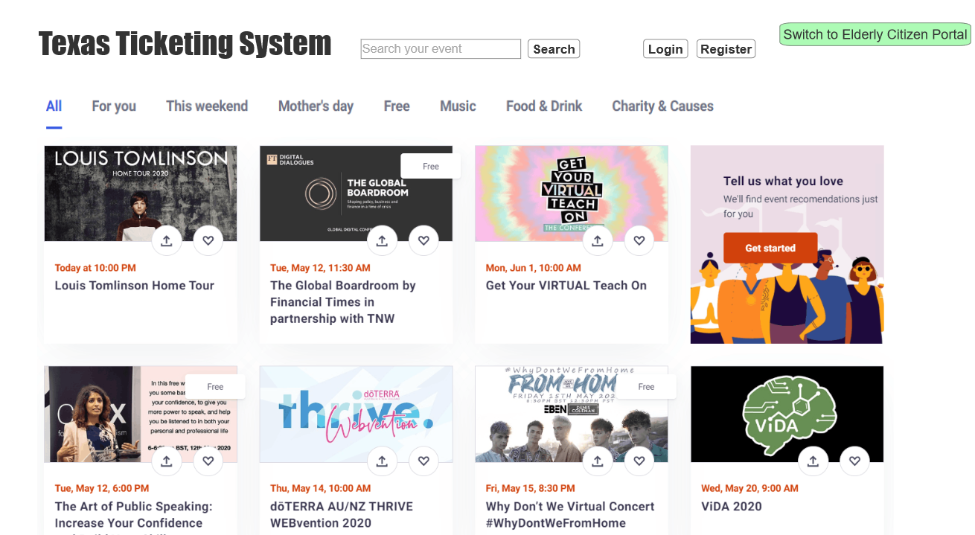

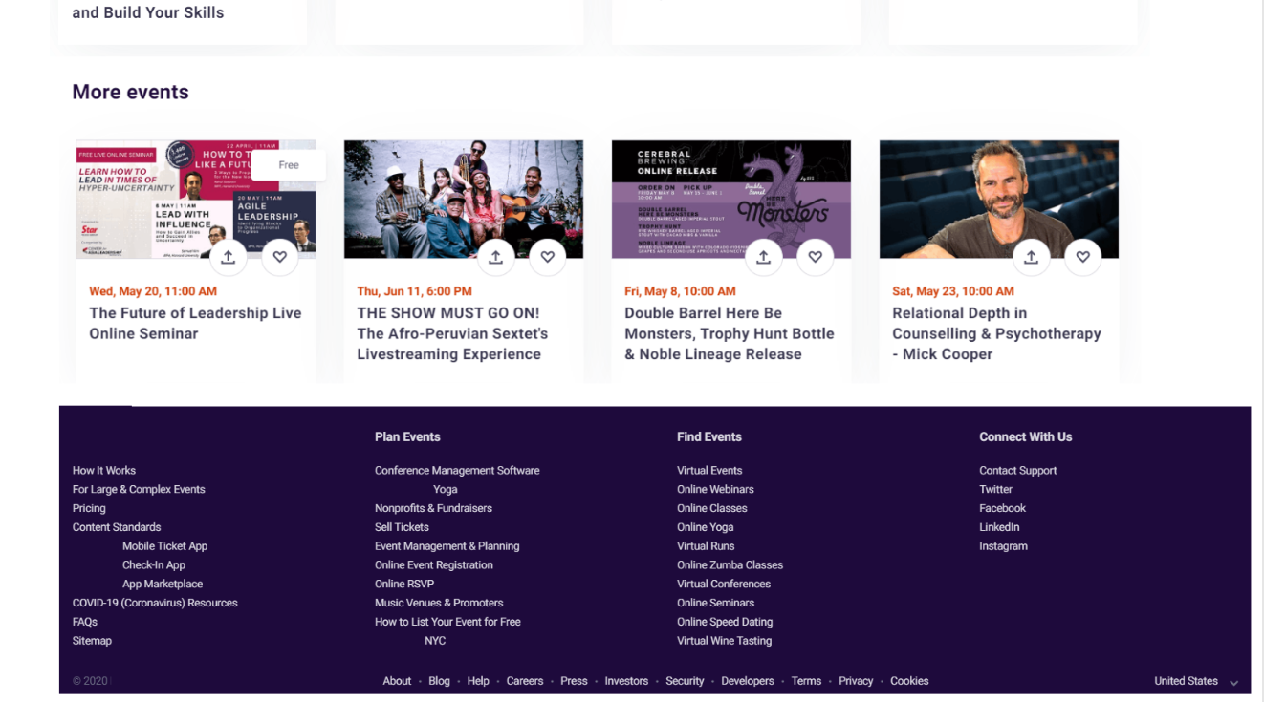

1. Here is the “Elderly Citizen Portal”: (**Designed** **simplicity for elderly citizens!**)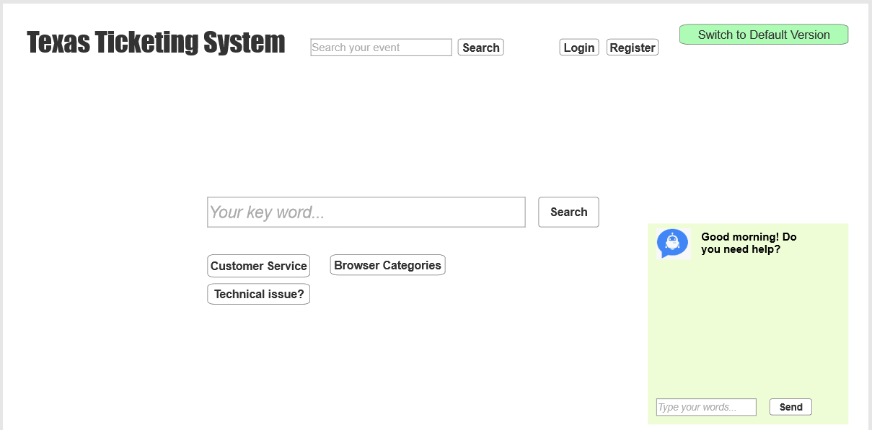

1. Begin to process payment:

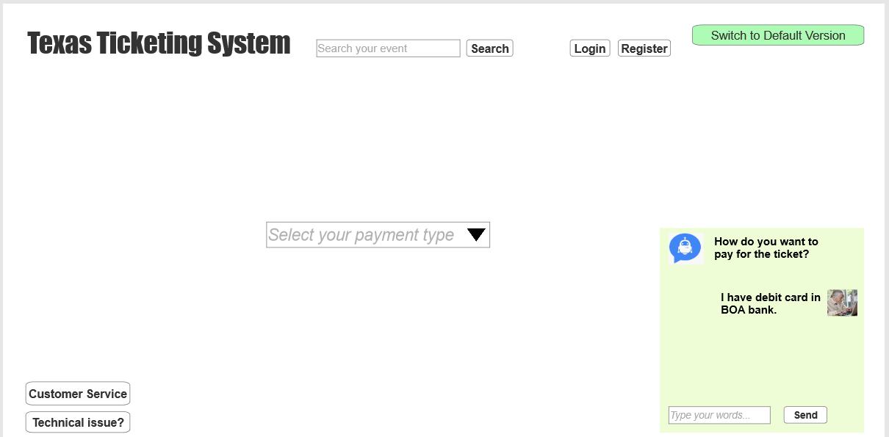

1. Fill the payment details:

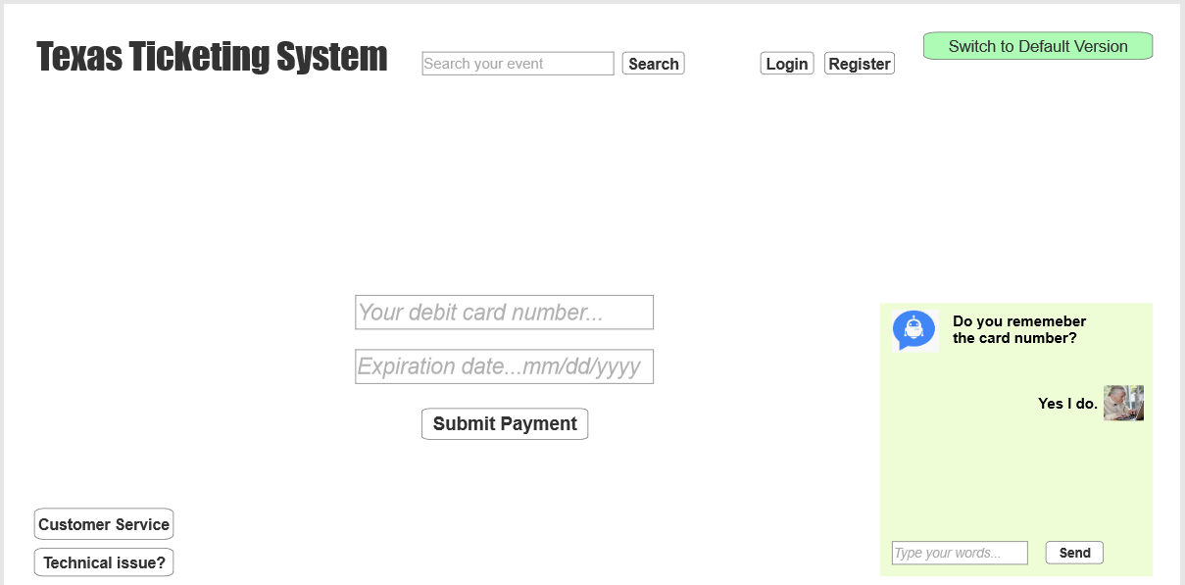

1. Traction finished:

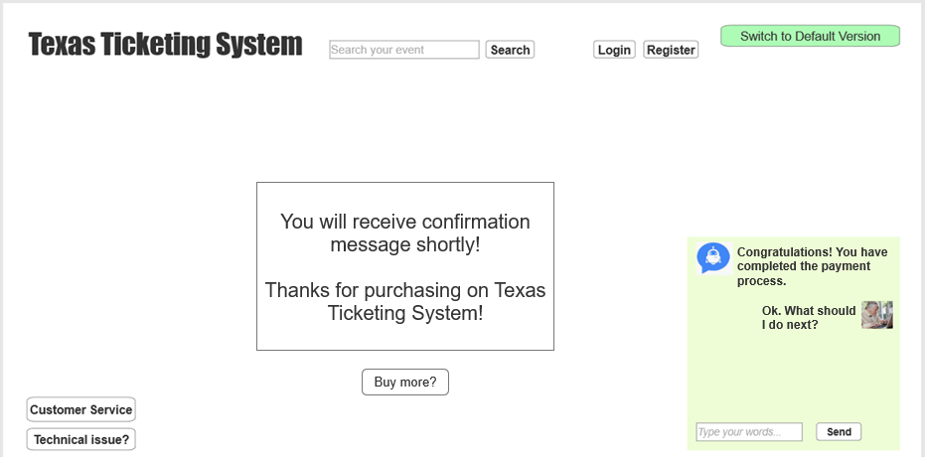

1. Want return to default version? Just click “**Switch to default version**”



# Evaluation of an Interactive Product

1. Based on your knowledge of the requirements for this system, develop a standard or typical task for a typical user to performed.

Based on the requirements from the stakeholder, we have two target customers.

* First, the public audience include people from age 18 – 55 years old. They normally know how to use computer very well and can cope with most of the tasks in the system.
* Second, the elderly citizens who normally are not familiar with the latest technology and live alone. They want to enjoy the shows and event while they have to do it independently

We will skip the first group people as the task will be the same as any other e-Commerce website. Now we will focus on the second group.

1. We will select 5-10 elderly citizens in Texas, maybe the relatives or friends’ grandparents.
2. Ask them to search recently shows (such as “Lone Star Law”) in google, to see if they can find our system correctly in the first or second attempt
3. See if you can directly open the show’s link through our system by open the google search result
4. Check if they would consider call technical support hotline before chatting with the virtual assistant bot.
5. Watch if they can independently choose the preferred time and theatre location
6. See if they would like to chat with virtual assistant bot when they feel difficult to use the system
7. See if they know how to pay online with their credit card or debit card. At least, see if they would like to follow the virtual assistant bot’s instruction.
8. Check if they can successfully receive confirmation message from the system.

1. Select three typical users and ask them to do the task using your prototype.

The three group users are:

* Young people age between 18-30

Virtual Feedback: they feel no press to use this system. The only complaint of the system is that when clicking the payment button, it take more than three seconds to show up.

* Foreigners who do not speak English very well with age below 50

Virtual Feedback: some of them do not have debit card but they do have credit cards from their own county. When trying to register, they cannot provide a local phone number. However, the system support guest purchase and send confirmation letter to their email address and phone number.

* Elderly citizen who live in Texas for more than 10 years.

Virtual Feedback: Most of them say the system is better than other system – because most of other system do not have “Elderly Citizen Portal”. Thus, they feel less pressure when using this system. Though they do not use bot that much, but the bot indeed can provide important information to help time finish the transaction.

1. Note the problems that each user encounters. Note their vocalizations, movements, posture, time to complete each of the tasks or sub-tasks, and their reactions after completing the task. If you can, time their performances to the nearest second. Document their performance using an available device (smartphone, camera, etc.).

Virtual online interview 1: Bob and his wife tried to book drama ticket on this system. They felt frustrated at the beginning because they never did that before. However, after 25 minutes, they finally found a good one and paid with their credit card online. They said the bot is a bit slow but it really helped.



Virtual online Interview 2: An senior engineer whose name is Tushar, feel the system is creative because of the “Elderly Citizen Portal”. However, he is a software architect, and he feel no press to use the default version. Also, he suggested that we can consider use Spring framework to rebuild the system and he believe the REST API can have speed up the system. Currently the JDBC connection consumes too much resource in backend.



Virtual online interview 3: This is the neighbor’s son who live in San Marcos. We let him to use this system and he is too young to be able understand the flow. However, he enjoy the communication with the bot. Though he didn’t complete the whole process, he spent lots of time talk to the bot and ask bot to find an online game for him. He is satisfied with the experience.

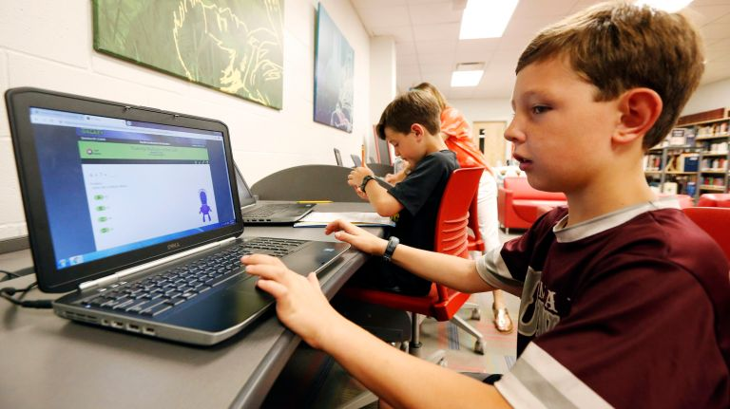

Virtual online interview 4: This is my father who are new to the system. He tried one hour and gave up. He do not understand English. Thus we believe we need to make the system bilingual.

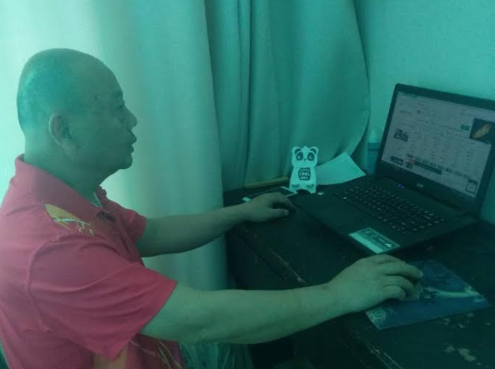

Virtual online interview 5: This is my mother who are new to the system too. He tried one hour and finished the transaction. She compliant the web response time. But she was excited to be able to chat with the AI bot.

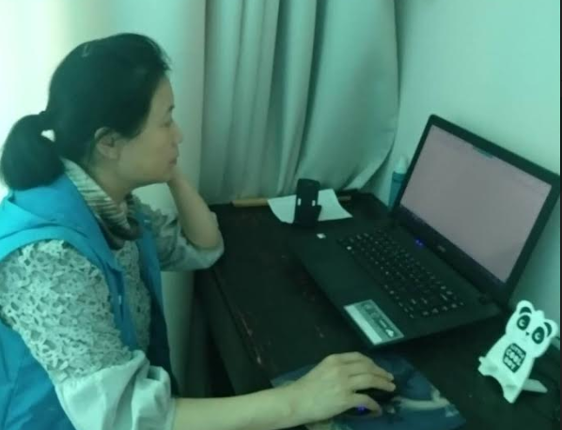

There are some other interviews like the system while some others compliant about the system speed. Later I realized we need to use better framework and abandoned the traditional design. Later we interviewed more people and they found the speed is better. Also, we beautified the front-end to make it user-friendly. Also, we updated the virtual assistant bot’ database, to make the AI response with more humanities.

1. At the end of this session you have the data to be used to evaluation of your interactive system. Make use of the examples shown in the evaluation chapter 14 to produce statistics. (Use the statistical measures available through Microsoft Excel or similar system.)

See below table.

As we can see here, the average time to complete the task is 12 minutes. And we found people spend much more time on dealing with online payment – even though they have the AI bot’s assistant.

On the other hand, 8% of the interviewees failed to complete the whole process. And 30% of the interviewee complete the task with 10 minutes. All of them found the system via google within 2 minutes after they open the browsers. Though they also spent some time on selecting the right show timeslot, it is relatively fast.

|  |  |  |  |  |  |  |  |
| --- | --- | --- | --- | --- | --- | --- | --- |
|  | **(Unit: minute)** | |  |  |  |  |  |
|  | Find the system | Find out the liked show | Selected the session | Finished payment | Received Confirmation Message | Total | Z-score |
| Interviewee 1 | 2 | 3 | 0.5 | 25 | 1 | 31.5 | 2.814121198 |
| Interviewee 2 | 1 | 1 | 0.5 | 15 | 1 | 18.5 | 0.934023096 |
| Interviewee 3 | 2 | 2 | 1 | 8 | 1 | 14 | 0.283219906 |
| Interviewee 4 | 1 | 1 | 2 | 3 | 1 | 8 | -0.584517679 |
| Interviewee 5 | 3 | 4 | 1 | 4 | 1 | 13 | 0.138596975 |
| Interviewee 6 | 3 | 2 | 4 | N/A | N/A | 9 | -0.439894748 |
| Interviewee 7 | 1 | 2 | 1 | 8 | 1 | 13 | 0.138596975 |
| Interviewee 8 | 2 | 1 | 1 | 3 | 1 | 8 | -0.584517679 |
| Interviewee 9 | 1 | 3 | 0.5 | 2 | 1 | 7.5 | -0.656829145 |
| Interviewee 10 | 1 | 2 | 1 | N/A | N/A | 4 | -1.163009403 |
| Interviewee 11 | 1 | 1 | 2 | 5 | 1 | 10 | -0.295271817 |
| Interviewee 12 | 2 | 2 | 1 | 2 | 1 | 8 | -0.584517679 |
|  |  |  |  |  |  |  |  |
|  |  |  |  | Median | 9.5 | Standard  Deviation | 6.914532803 |
|  |  |  |  | Average | 12.04166667 |

1. Write a summary of your evaluation and conclusions regarding the entire system as it currently exists.

We evaluate by several aspects:

1. Accessibility

The SEO did a good job. So the user can easily found our research by searching “Ticketing system” or any events’ name such as “Lone Star Law”, etc. However, if you search it when you are in other state (for example when you are in New York), you may not be able to find it easily

1. Emotional AI

The website’s color and design is warm. With green theme, people will feel more delightful when using it. Also the “Elderly Citizen Portal” provide much easier interface for user to interactive with bot. Mostly importantly, the AI tool – virtual assistant bot can give comforting words such as “Take your time Sir” and “You did a great job”, etc, etc.

1. System speed

It becomes an initial problem at the beginning because users felt frustrated when waiting for the web page’s response. But later we updated with Spring framework, the feedback is better. And we believe currently the system is acceptable for most of the users. All the confirmation message will send out within 10 seconds of the transaction finish.

1. Security

It can be a dilemma. Based on the current budge, we could not be able to incorporate advanced anti-hacker software. On the other side, this ticketing system only cope with small amount of transaction. Thus, the security level is not necessary as high as banking system. However, we do realize the database which store the customer data is very sensitive. We will continue give more protect to the database and will add on two factor verification process in future when user want to login or want to purchase online.

1. How many users can transaction at the same time?

So far we simulated 100 users to transact at the same time and no problem found. But in case we have more user, we adopt the queue mechanism – which means any time we only process maximum 100 transaction request

1. iPad compatibility

It works perfectly well with iPad Pro and iPad air. The system work OK on the safari browser.

1. Google Analytics

The test on google analytics can be more informative. And we will continue monitor on this platform and test the visiting frequency. Interesting thing is that, two visitors from German were detected. We assume it is because some cloud server are located there.